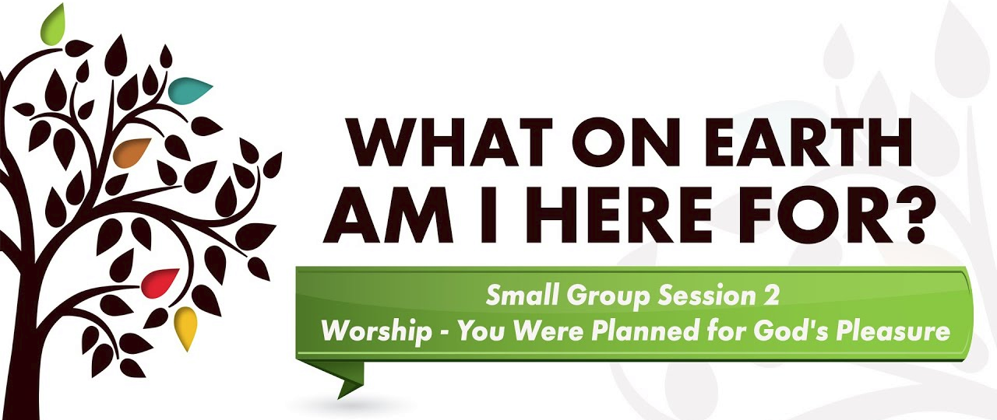

- Ice-breaker question - what is your earliest memory of church?
- Opening prayer
- Give members an opportunity to share 1 thing that spoke to them from last week’s reading
- Watch Video

Discussion Questions:
1. What new insight did you gain from the video segment?

2. Worship is expressing your affection to God. What are some ways we can express our affection to God? What gets in the way of you focusing your affections and attention on God on a daily basis?

3. What are some steps you can take to get to know God better? What can you do to learn to love him more?

4. Can rules and rituals get in the way of true worship? How do rules and rituals assist us in loving God and living in a right relationship with him?

5. Surrendering to God is not about losing, it’s about gaining. What do you gain by surrendering more of your life to God?

6. What have you found helpful in establishing a daily time with God? How have you developed a constant conversation with the Lord?

7. Why do we tend to compartmentalize our worship to one day a week, in one particular location? What practical steps can we take to involve God in every area of our lives?

Assignment: Read Days 8-14 of The Purpose Driven Life. Mark any passages that jump out at you.

SUGGESTIONS FOR GROWING IN WORSHIP
Pick 1 or 2 small things that you can commit to

Practicing the presence of God: this involves looking for God in every detail of life. To do this you may want to think of God as ever-present in every situation, and remember you are never alone. Look at everything you do not as something you do by yourself, but something you do together with God. Spend time speaking with Jesus as if he were right there with you.

Fasting: The purpose of a traditional fast is to abstain from food in order to focus clearly on your relationship with God. You can also fast from television, entertainment, reading, or anything that distracts you from God. During the fast, commit the time you would have spent on the activity you are fasting from to prayer, bible study, worship, etc. Use it as a time to focus on God.

Journaling: Sometimes it is helpful to journal in order to see God’s work in our lives. You may
want to start a journal that allows you to record some of the victories and struggles you are having. Record your thoughts and feelings as you go through a process of self-examination. Make it a point to review your journal annually to see how God has worked in your life over the past year.

Worship: Find a place where you can worship God privately. It may be a spot outdoors, in the
privacy of your bedroom, or even in your car while commuting to work with a good worship CD.
Wherever it is, make a habit of visiting this place regularly and worshiping God there.

Meditate on God: Take some time to meditate on who God is and to get a sense of his
greatness. You may want to use the Psalms as a guide. Read through a Psalm and note what the psalmist says about God’s character and about his experiences with God. Take some time to praise God for who he is and for what he has done in your life.

Worship as a Lifestyle: When you wake, thank God for the day. As you go to work or school, sing praise music or adore him for who he is. Throughout the day, try to commit every word, thought, and action to him as a way of thanking him and worshiping him, realizing every breath is his gift to us. At home, bring God into every activity. Talk with others about the things God has done in your life.

Preparation for Mass: Spend some time preparing yourself for Mass. As you approach the building, take a moment to stop and thank God for your church. Before Mass begins, say a prayer of thanks to God. Tell him you are looking forward to meeting him in worship. Pray that God would prepare your heart to worship him. Spend some time praying for the priest and everyone involved in worship that day. Look around at those entering the church and pray for as many as you can specifically that God would touch their hearts and souls during the Mass. During the Eucharist, try to picture Christ seated on the throne and thank him for his sacrifice.

